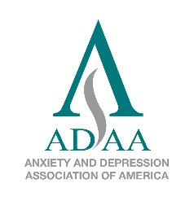
Anxiety and Depression Association of America

Board of Directors Nomination

Deadline: November 18, 2016

Nominee: Name_________________________________________ Degree(s)_____________________

E-mail_______________________________________________ Phone__________________________

Year joined ADAA_______________________

Practice or institution____________________________________________________________________

Street address_________________________________________________________________________

City_________________________________________ State_________ Zip_______ Country___________

Nominator (if different from nominee): Name__________________________________________________

Degree(s) ___________________ E-mail______________________________ Phone_________________

Practice or institution______________________________________________________________________

Signature of nominee (or nominator _____________________________________ Date________________

Describe what you hope to contribute and gain by serving on the ADAA Board of Directors; include relevant experiences and positions in other organizations (up to 750 words).

_______________________________________________________________________________________

List your ADAA involvement (committees, special interest groups, conferences attended, presentations, etc.)

_______________________________________________________________________________________

___ I have included my CV.
___ I have included a cover letter of nomination for myself or from a nominator, or ___ I’ll do so separately.
___ I understand that nominations for the Board of Directors must be postmarked by November 18, 2016, or they will not be accepted.

Complete this application electronically.
1. Save it to your computer.
2. Type in all the highlighted fields, including signature field.
3. Save, rename with your name, and e-mail as an attachment.
4. E-mail CV and cover letter as separate attachments.

Deadline: November 18, 2016

