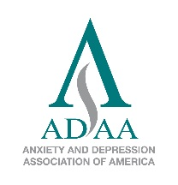

ADAA Member Recognition Awards
2018 Nomination Form

Deadline: October 2, 2017

Please complete a separate application for each award.
_____ Jerilyn Ross Clinician Advocate Award OR _____ ADAA Member of Distinction
Member of Distinction Award
Nominator: __________________________ Nominator Email: _______________________
Nominee Name: ______________________ Degree: ________________________
Nominee Email: ______________________ Nominee Phone: _________________________

List two references for the Awards Committee to contact for additional recommendations, if necessary:

- Name: ______________________ Email: _______________________
- Name: ______________________ Email: _______________________

Describe the service and contributions that demonstrate the candidate’s exemplary commitment to ADAA that includes the candidate’s service and contributions, such as committees, task forces and boards, mentoring, special initiatives, conference participation, and other important distinctions (500 words).

Jerilyn Ross Clinician Advocate Award
Nominator: __________________________ Nominator Email: _______________________
Nominee Name: ______________________ Degree: ________________________
Nominee Email: ______________________ Nominee Phone: _________________________

List two references for the Awards Committee to contact for additional recommendations, if necessary:

- Name: ______________________ Email: _______________________
- Name: ______________________ Email: _______________________

Describe below how this candidate demonstrates a commitment to empirically supported clinical care and/or innovation, as well as advocacy defined as significant outreach to the public, legislators, or health professionals to disseminate knowledge and advance awareness and care of anxiety disorders (500 words).

