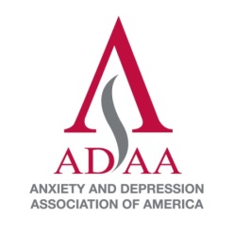
Anxiety and Depression Association of America
CLINICIAN TRAINEE AWARD
2016 Application

Deadline: December 1, 2015

Submit this completed application, current CV, and letter of recommendation by e-mail: awards@adaa.org; postal service: ADAA Awards, 8701 Georgia Ave, Suite 412, Silver Spring MD 20910; or fax 240-485-1035. Questions? Contact awards@adaa.org.

Please visit the ADAA website for award eligibility and selection criteria.

First Name: ______________________________________________ Last Name ____________________________________________________

Highest Degree(s)/Year/Institution _____________________________________________________________________________________

State License (if applicable) ______________________________________________________________________________________________

ADAA member yes no Year joined _________ Number of prior ADAA conferences attended? _______

Current Institution or Practice ___________________________________________________________________________________________

Mailing Address ___________________________________________________________________________________________________________

Phone: Work ___________________________ Cell ___________________________ E-mail________________________________________

Letter of recommendation will be submitted by ________________________________________________________________________

If selected to participate, I agree to the following:
I will attend the ADAA Annual Conference, March 31 – April 3, 2016 (registration fee will be awarded).
I will cover all expenses related to travel to Philadelphia, meals not included in the program or conference, and lodging.

Applicant Signature________________________________________________________ Date__________________________________________

Personal Statement (500 words maximum)
Please describe your career goals and specifically highlight your practice interests in anxiety disorders and depression (include your theoretical orientation to practice). Address why you want to attend the Annual Conference and how this will benefit you. Explain how you plan to serve as a leader within ADAA as your career progresses.

Case Report Abstract
Please describe an interesting case you have encountered in your training. Include the following four categories:

- Case diagnosis – 350 Words
- Case description – 350 Words
- Discussion – 350 Words
- Conclusions – 350 Words

Maintain the confidentiality of the patient or client.

